PERSONAL BOOKMARK MANAGER
@CREATIVITY THINK (9483175986/7019689991)

ABSTRACT:
The Personal Bookmark Manager is a dynamic web application designed to help users save, categorize, and manage their favorite web links efficiently. Users can add URLs, assign tags for categorization, search through saved bookmarks, and export their collection as a CSV file. Administrators have access to basic user management through Django Admin. The system, developed using Django for the backend and React with axios for frontend interactions, provides a simple yet effective solution for organizing online resources and research materials. This application is lightweight, low-level, and ideal for personal or small-scale usage..

INTRODUCTION OF THE PROJECT:
Managing large volumes of web links manually can be tedious and prone to loss or misorganization. The Personal Bookmark Manager addresses this by providing a structured system for saving URLs, tagging them for easy retrieval, and searching through stored bookmarks efficiently. Users can also export their collections for backup or sharing purposes. With Django handling backend logic and React managing frontend rendering and API calls, the system offers a seamless and responsive user experience..

PROJECT OBJECTIVES:

• Enable users to save and manage URLs efficiently
• Provide a tagging system for easy categorization
• Allow users to search through saved bookmarks
• Support exporting bookmarks in CSV format
• Offer a lightweight, easy-to-use interface
• Provide basic administrative controls for user management
• Ensure data persistence and retrieval through a structured database

PROBLEM OF THE STATEMENT:
Many users save links using browser bookmarks or unorganized spreadsheets, which lack categorization, search, and export capabilities. This makes finding and managing links time-consuming and inefficient. The Personal Bookmark Manager provides a centralized, searchable, and organized solution for saving web links with tagging and export features, ensuring that important resources are easy to access and manage..

MOTIVATION OF THE PROJECT:
• To simplify saving and organizing web links
• To provide categorization and tagging for easy retrieval
• To offer search functionality for large collections
• To enable exporting of saved URLs for backup or sharing
• To provide a lightweight, personal-level application for research and productivity
• To reduce reliance on browser bookmarks or spreadsheets

BLOCK DAIGRAM OF PROJECT:

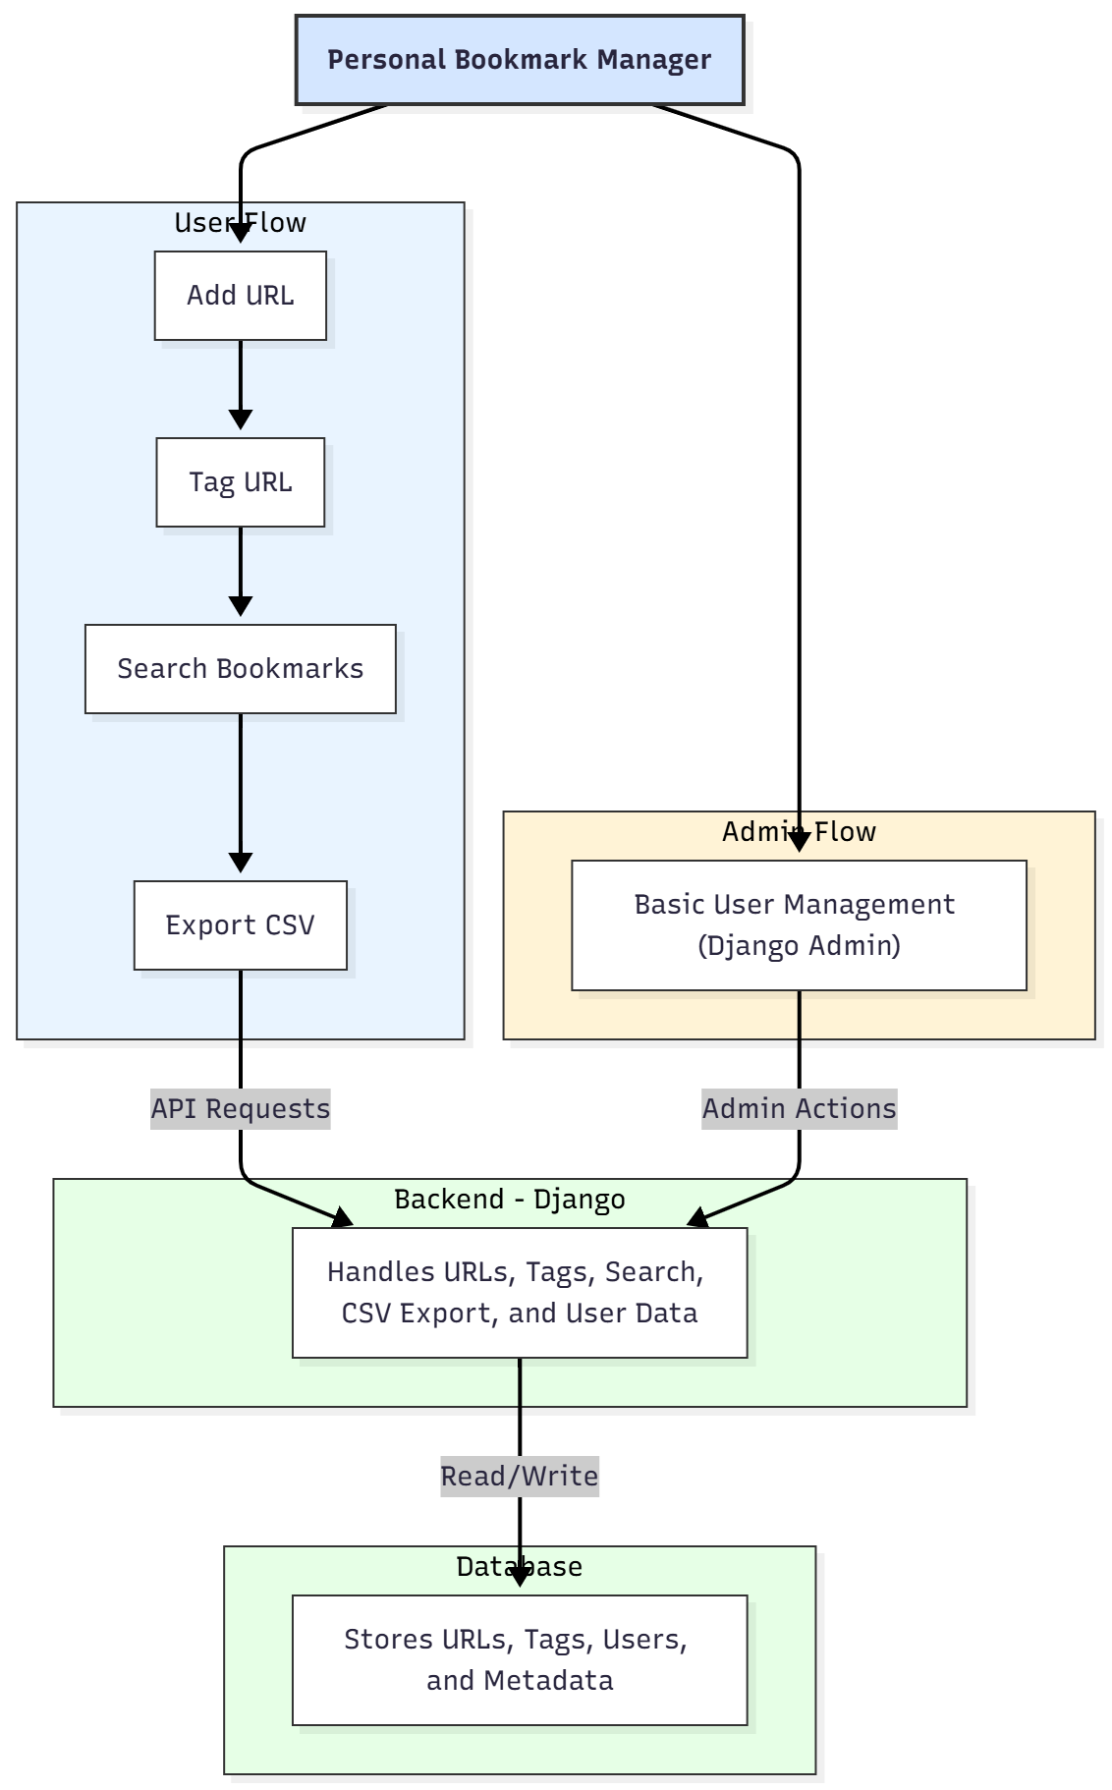

WORKING OF THE PROJECT:
Users can add URLs to the system and assign tags for better organization. The search function allows retrieval of specific bookmarks by keywords or tags. Users can export all saved bookmarks in CSV format for backup or sharing. Administrators access Django Admin to manage users, ensuring proper access control and system oversight. The backend handles storage, retrieval, tagging, and export functionalities, while the database stores URLs, tags, user data, and metadata securely. This workflow ensures a lightweight, efficient, and user-friendly bookmark management experience..

SOFTWARE REQUIREMENT:
- Backend:
  - Python 3.x
  - Django
  - Django REST Framework
  - SQLite/PostgreSQL
- Frontend:
  - Node.js and npm
  - React.js
  - Axios
- Development Tools:
  - Visual Studio Code
  - Postman (for testing APIs)
  - Git/GitHub (for version control)
- Server/Deployment (Optional):
  - Gunicorn, Nginx, or Heroku/AWS for hosting

ADVANTAGES OF THE PROJECT:

• Centralized management of web links
• Tagging system for categorization
• Search functionality for easy retrieval
• Export option for backups and sharing
• Lightweight and user-friendly interface
• Simple administrative oversight via Django Admin
• Suitable for personal or small-scale research use

APPLICATIONS OF THE PROJECT:
• Personal bookmark management
• Research link organization
• Academic and study resource management
• Small teams sharing reference URLs
• Backup and export of curated online resources

REFERENCES:

- Django REST Framework Documentation — Django Software Foundation. Django Documentation. Available: https://docs.djangoproject.com/
- Django REST Framework. DRF Documentation. Available: https://www.django-rest-framework.org/
- React. React Official Documentation. Available: https://reactjs.org/docs/getting-started.html
- Redux. Redux Documentation. Available: https://redux.js.org/introduction/getting-started
- PostgreSQL Global Development Group. PostgreSQL Documentation. Available: https://www.postgresql.org/docs/
- MySQL. MySQL Reference Manual. Available: https://dev.mysql.com/doc/
- Git. Git Documentation. Available: https://git-scm.com/doc
- Node.js. Node.js Documentation. Available: https://nodejs.org/en/docs/
- Axios. Axios Documentation. Available: https://axios-http.com/docs/intro
- Socket.io Documentation – https://socket.io/docs/

